Cauchy's integral theorem

Intro

Def

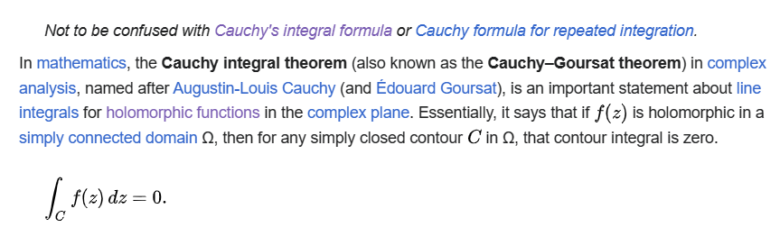

Statement

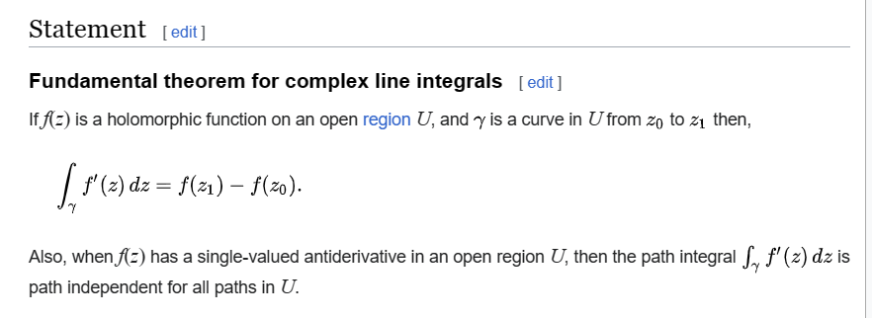

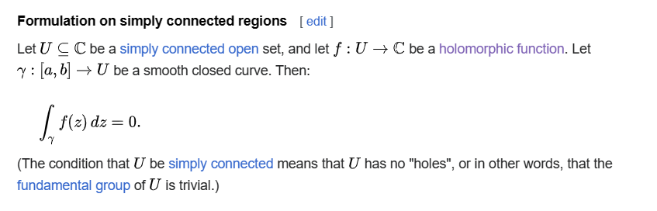

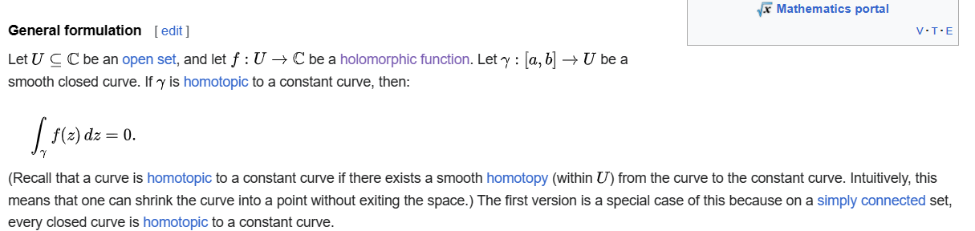

Let $$U$$ belongs to $$C$$ be an open set.

Let $$f:U→C$$ be a holomorphic function.

Let $$r:\left[a,b\right]→U$$ be a smooth closed curve.

If $$r$$ is homotopic to a constant value, one has that

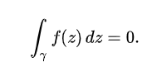



Proof

Method 1:

Method 2:

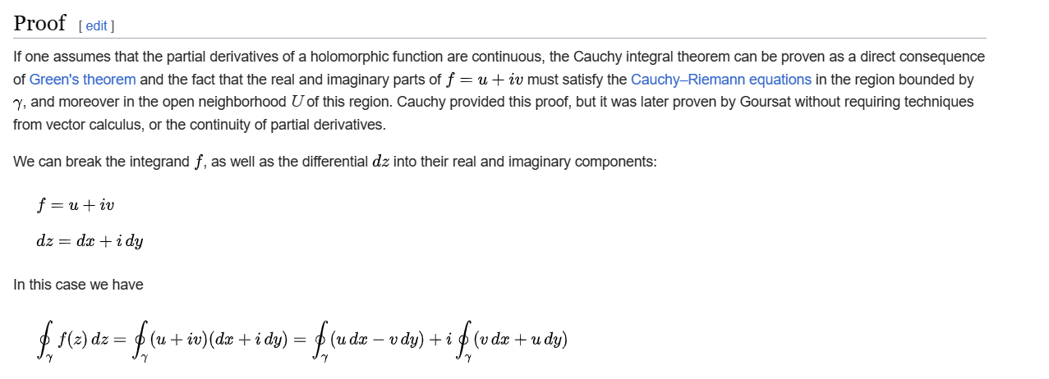

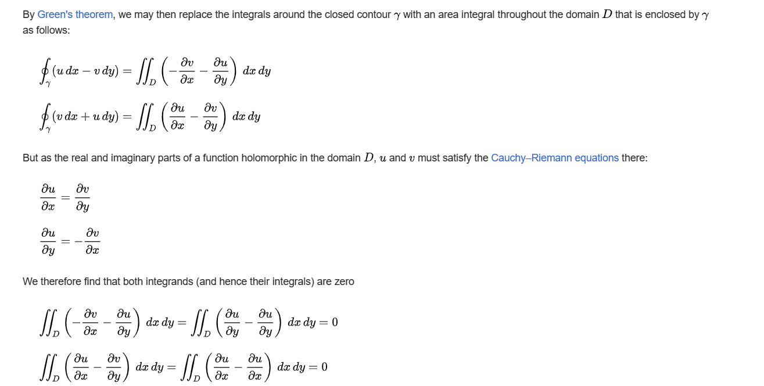

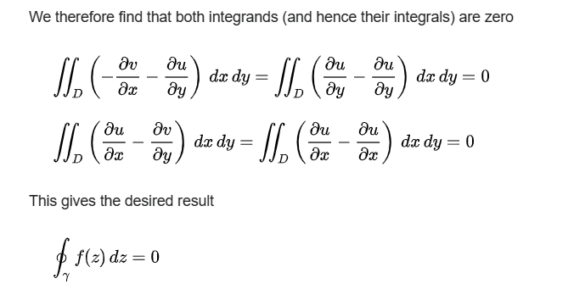

Ref

[Cauchy's integral theorem - Wikipedia](https://en.wikipedia.org/wiki/Cauchy%27s_integral_theorem)